EVEREST ENGINEERING COLLEGE

(Affiliated to Pokhara University)

Sanepa - 02, Lalitpur



Assignment
of
Operating System Design and Implementation

Submitted by

Er. BABURAM SHRESTHA

Submitted to
Dr. KUL PRASHAD SUBEDI

Date: 19 Jan 2025

Assignment-1

Question No.1
Download the source code from this link:
https://github.com/kpsubedi/OS/blob/master/linux/process_hw1.c. Answer the following
A. comments the lines 8-10. compile and run the code. Submit the output of the program and explain why you receive the output. [10]
Answer:
From the given code after commenting the lines 8-10 I got the following output of the program.
Output:
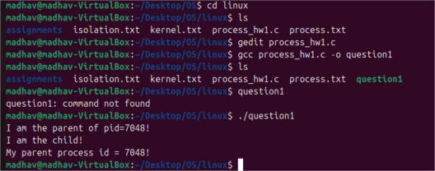Explanation
Process Tree:
Each fork() doubles the number of processes:
First fork(): Creates 2 processes.
P1: Original parent process.
C1: Child process created by P1.
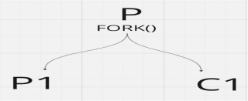
Behavior of fork():
fork() creates a new child process.
The parent process receives the PID of the child process in the variable pid.
The child process receives 0 in the variable pid.
Execution Flow:
After fork(), two processes execute:
Parent Process:
Executes the block where pid > 0.
Prints: I am the parent of pid=7048! (where 7048 is the PID of the child process). Child Process:
Executes the block where pid == 0.
Prints: I am the child! and My parent process id = 7048! (where 7048 is the PID of the parent process). Concurrency:
The two processes execute concurrently, so the order of their outputs may vary. Typically, the parent process finishes first, but this is not guaranteed.
Key Points to Note
Only one child process is created because a single fork() is called because comment insert to line no 8-10 The parent process prints information about the child, while the child process prints its own details. The total number of processes running is 2 (parent and child).
B. comment the lines 9-10. compile and run the code. Submit the output of the program and explain why you receive the output. [10]
Answer:
From the given code after commenting the lines 9-10 I got the following output of the program. 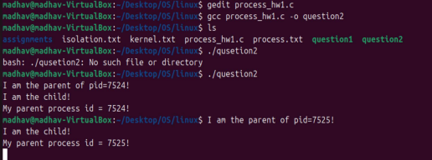Process Tree
Each fork() doubles the number of processes:
First fork(): Creates 2 processes.
P1: Original parent process.
C1: Child process created by P1.
Second fork(): Both P1 and C1 execute this fork() independently, creating:
P1 creates C2.
C1 creates C3.
Process Flow Tree:
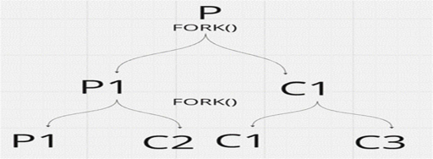
Execution Flow
P1 (Parent Process):
Executes both fork() calls.
After the first fork, it becomes the parent of C1.
After the second fork, it becomes the parent of C2.
C1 (Child of P1 from First Fork):
Executes the second fork() and becomes the parent of C3.
C2 (Child of P1 from Second Fork):
Does not execute any further fork() calls (no new children created).
C3 (Child of C1 from Second Fork):
Does not execute any further fork() calls (no new children created).
C. comment the lines 10. compile and run the code. Submit the output of the program and explain why you receive the output. [10]
Answer:
From the given code after commenting the lines 10 I got the following output of the program. 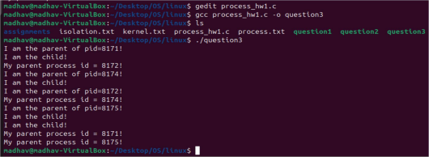
Process Tree Analysis
First fork(): Creates 2 processes:
P1: Original parent process.
C1: Child process created by P1.
Second fork(): Both processes (P1 and C1) execute this fork():
P1 creates C2.
C1 creates C3.
At this point, there are 4 processes: P1, C1, C2, C3.
Third fork(): All existing processes (P1, C1, C2, C3) execute this fork(). Each creates one child: P1 creates C4.
C1 creates C5.
C2 creates C6.
C3 creates C7.
At this point, there are 8 processes: P1, C1, C2, C3, C4, C5, C6, C7.
Process Flow Tree:
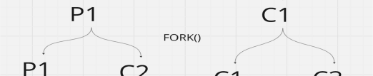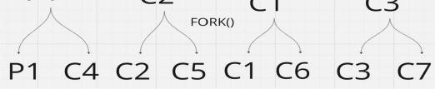Execution Flow
The program starts with only 1 process:
P (Parent Process, PID of the program).
First fork()
The first fork() creates a new child process, C1. Now, there are 2 processes:
P1: The original process.
C1: A new child process created by P.
Both P1 and C1 continue executing the same code from the point after the first fork().
Each process independently executes the subsequent code.
Second fork()
Both P1 and C1 execute the second fork() independently, creating 2 new child processes: P1 creates C2.
C1 creates C3.
Now, there are 4 processes:
P1 (Parent process).
C1 (Child of P1 from the first fork).
C2 (Child of P1 from the second fork).
C3 (Child of C1 from the second fork).
All 4 processes (P1, C1, C2, and C3) continue executing the subsequent code from the point after the second fork().
Third fork()
All 4 processes (P1, C1, C2, and C3) execute the Third fork(), each creating a new child process: P1 creates C4.
C1 creates C5.
C2 creates C6.
C3 creates C7.
Now, there are 8 processes in total:
P1, C1, C2, C3 (existing processes).
C4, C5, C6, C7 (new child processes created in the Third fork()).
All 8 processes independently execute the remaining code, including the if-else block.
Process Flow Tree Overall Code:
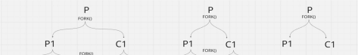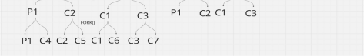
Q2. Execute the command :() {:|:&};: on the Linux VM. Explain how this command works. [20]
: IS function name
Ls & run program in background and recursive and use for maximum resource
Os three types
Windows @ p file
Linux @ELF(binary file)
Iso @macro
magicbyte
definitation of ls in os
which ls
strace ls
fork() to create process of making child
execve load child process code to parent
l called pipe two program link and take input to next of frist output
like
ls l grep madhav
take input
ps -ef l program name vim and see process id
kill –l
to find bug
is there bug or not go to website (canyouhack.us)
study how web browser work
go to developer tools
view page
sildes and books for operating system
https://pages.cs.wisc.edu/~remzi/OSTEP/
https://wiki.osdev.org/Expanded_Main_Page
https://www.os-book.com/
https://www.os-book.com/OS10/slide-dir/index.html@ for slides
https://github.com/kpsubedi/computer_architecture/blob/master/linux_assembly/lab_setup
https://github.com/kpsubedi/computer_architecture/blob/master/linux_assembly/assembly 32/what_is_assembly.org
https://github.com/kpsubedi/computer_architecture/blob/master/prerequisite/gdb_guide https://github.com/kpsubedi/computer_architecture/blob/master/prerequisite/tools
Important links and materials for threads
@ course study for security
https://cs155.stanford.edu/
@ to find bug go to
https://canyouhack.us/
@ notes on threads
https://learn.microsoft.com/en-us/windows/win32/procthread/fibers @ to check dll file go to
https://www.virustotal.com/gui/home/upload

